

**Thank you for choosing Lattimore PT! In order to serve you properly, we need the following information. Please print legibly. All information needs to be completed. Information will be confidential.**

**_____________________________________________________________________________**

Patient Name _________________________________________________ Male ____ Female ____ D.O.B. ____ /____ /_____

***\*\* as recognized by insurance company \*\****

Address ____________________________________________ City ___________________ State ______ Zip _____________

Home # ___________________ Cell ___________________ May we leave voicemail? Yes ___ No ___

**Appointment reminders – please check all that apply**: ____ Text message ___ Email ___ Phone Call

Email Address _____________________________________________ Authorization to use email address? Yes ___ No ___

Referring Physician __________________________________ Primary Care Physician _________________________________

Body part(s) being treated____________________________________________ **RIGHT LEFT**

Date of Injury or Onset: ______________________ Date of Surgery (if applicable): _____________________

How did you hear about Us? ______________________________________________________________________________

**Have you received PT this calendar year**?Yes ­­­___ No ___ **If Yes,** was it for the same condition? Yes ___ No ___

Is this in any way related to **Workers Comp** or **No Fault?** Yes____No____

**(If yes, please fill out worker’s comp or no fault insurance sheet and your backup medical insurance)**

**Emergency Contact(s)**

**Emergency contact**: ______________________________ **Relationship:** ___________________ **Phone:** ________________

May we leave a message? Yes ___ No ___ May we release PHI (Personal Health Information)? Yes ___ No ___

**Emergency contact**: ______________________________ **Relationship:** ___________________ **Phone:** ________________

May we leave a message? Yes ___ No ___ May we release PHI (Personal Health Information)? Yes ___ No ___

**Please designate a Star (*) next to either emergency contact that you would like to designate as a personal representative, one who will make or change your appointments.**

If we may **NOT** release your information, to anyone other than your doctors, insurance company, and yourself; please initial below.

**____ Lattimore Physical Therapy does not have my permission to release any PHI.**

**I acknowledge and agree that Lattimore Physical Therapy may disclose my personal health information to designated contact(s)**

_______________________________ __________________________________ _________________________ **Print Name**  **Signature of patient, parent or guardian** **Date**

**Lattimore of Physical Therapy and Sports Rehabilitation Network**

**Financial Policy**

**Payments and/or Copay(s) are expected at the time services** **are rendered,**

unless specific credit arrangements are made in advance.

**Patients with Medicare:** Claims will be submitted to Medicare on the patient’s behalf. Patients are responsible for an annual deductible and 20% coinsurance. A claim will be sent to your supplemental insurance when information is provided by the patient. If a balance remains after insurance(s) have reviewed and made any payments on claims, you will then become responsible for that final payment.

**Patients with Insurance:**  Patients are responsible for deductibles, co-payment, non-covered service, coinsurance, and items considered “not medically necessary” by the insurance company. A claim will be submitted to the insurance company when LPT is provided with the necessary billing information. Any remaining balance is due from the patient within a timely manner. If a patient or an insurance carrier pays an amount exceeding the balance, a refund will be issued to the appropriate party.

**Patients with high deductible Insurance:** Patients are responsible to pay out of pocket until the deductible is met. The fee for physical therapy services are set by your insurance company. We are unable to discount fees set by your insurance company. We are requesting that the patients with high deductible plans make a pre-payment at each visit at each visit and we will balance bill if your pre-pay per visit is lower than the insurance company allowed amount. If you are not willing to make a pre-payment, we will expect payment in full within 30 days of receiving a statement from our office.

**Visits per Calendar year:** Your insurance may set limitations of the number of visits allowed per calendar year. If you exceed that visit number you may be responsible for charges. The office will discuss the options available with you.

**Patient Insurance Verification**

We do our very best at Lattimore to verify your Health Insurance in order to determine your proper copay, co-insurance / deductible / visit limit and if your plan is in or out of network. We cannot, however, be responsible if your plan pays differently than what we were told. Verification process is very time consuming and complicated. It is in your best interest to call your insurance to verify what your benefits will be for Physical Therapy at our Practice and Location. We will also bill to your secondary insurance as a courtesy and if there is any balance due, you will be held accountable.

**Assignment of Benefits**

I understand and agree that I am personally responsible for full payment of all physical therapy services rendered to me. I hereby transfer/assign payment of any physical therapy insurance benefits directly to **Shuman Physical Therapy Associates, P.C., and all locations associated to this corporation** and authorize release of any information regarding my treatment that is required by my insurance carrier to obtain such a payment.

**Appointment – Cancellation and NO Show Policy**

We are committed to providing you, our valued patients, excellent quality and convenient physical therapy services. **In consideration of our other patients and our staff we do require 24 hour notice for appointment cancellations**. **Not showing for an appointment creates a financial and scheduling burden, therefore we are forced to charge the fees below:**

**MISSED APPOINTMENT FEES:**

**Cancellations less than 24 hr notice will result in fees of $20 per instance. No Show appointments are $30 per instance.**

**Lattimore Physical Therapy and Sports Rehabilitation Network**

At Lattimore Physical Therapy we respect our patient’s right to privacy at all times. As required by the **Health Information Portability and Accountability Act** (HIPAA) we adhere to the standard set for in the **Notice of Privacy Practice** provided with your paperwork. **HIPAA privacy notice** copies are available upon request. This document states that we reserve the right to contact you by mail or phone. We may leave a message regarding appointment confirmation, scheduling payment for service and treatment issues. By signing this agreement, you are granting us permission to do so. I hereby acknowledge that I have received a copy of Lattimore Physical Therapy’s Notice of Privacy Practices.

**If you have any questions or concerns regarding the above information, please call Lisa Hoover at 585-582-0007.**

**I have read and reviewed our office(s) policies and procedures as described above. I have additionally acknowledged Lattimore Physical Therapy HIPAA policy to protect your personal health information**

_____________________________ _____________________________________ ________________

**Print Name Signature Patient, Parent or Guardian** **Date**



**DO YOU HAVE OR HAVE HAD:**

1. YES NO High or Low blood pressure 16. YES NO A stroke, head injury, concussion, loss of consciousness
2. YES NO Heart problems (murmur, abnormal rate, etc) 17. YES NO Depression
3. YES NO A pacemaker 18. YES NO Muscular disease (multiple sclerosis, polio
4. YES NO Angina (chest pain) cerebral palsy, ALS, etc)
5. YES NO Shortness of breath 19. YES NO Fainting spells, seizures, epilepsy, or dizziness
6. YES NO Asthma 20. YES NO Arthritis
7. YES NO Lung conditions (bronchitis, emphysema, pneumonia) 21. YES NO A history of fibromyalgia, or chronic fatigue syndrome
8. YES NO Recent unintentional weight gain / loss 22. YES NO Skin conditions (shingles, eczema, psoriasis, rashes)
9. YES NO Loss of appetite, prolonged nausea, vomiting 23. YES NO Infectious diseases (MRSA, C-diff, Tuberculosis)
10. YES NO Liver disease (hepatitis, jaundice) 24. YES NO Smoking history
11. YES NO Kidney or bladder problems (urgency, frequency, 25. YES NO Hearing Loss

bloody, incontinence, retention) 26. YES NO Osteoporosis or osteopenia

1. YES NO Bowel (constipation, diarrhea, bloody, Incontinence) 27. YES NO Headaches (recurrent or chronic)
2. YES NO Thyroid problems (hypo or hyper) 28. YES NO Allergies to medications / food / other:
3. YES NO Diabetes (high or low blood sugar) **Please note:** _______________________________
4. YES NO Cancer **Type:** _____________________________

**Current Medications (include non-prescription) Surgical History Date**

__________________________________________________ __________________________________ ______________

__________________________________________________ __________________________________ ______________

__________________________________________________ __________________________________ ______________

__________________________________________________ __________________________________ ______________

(Optional) Please report any daily activities/tasks that result in a marked increase in your symptoms:

1. ________________________ 2. ________________________ 3. _______________________

**Please Circle AVERAGE Pain Level:**

**Please draw your symptoms based on the key below:**

*XXXX* = Aching *ZZZZ* = Sharp

*^^^^* = Burning *0000* = Numbness/Tingling

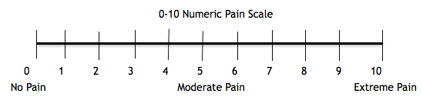

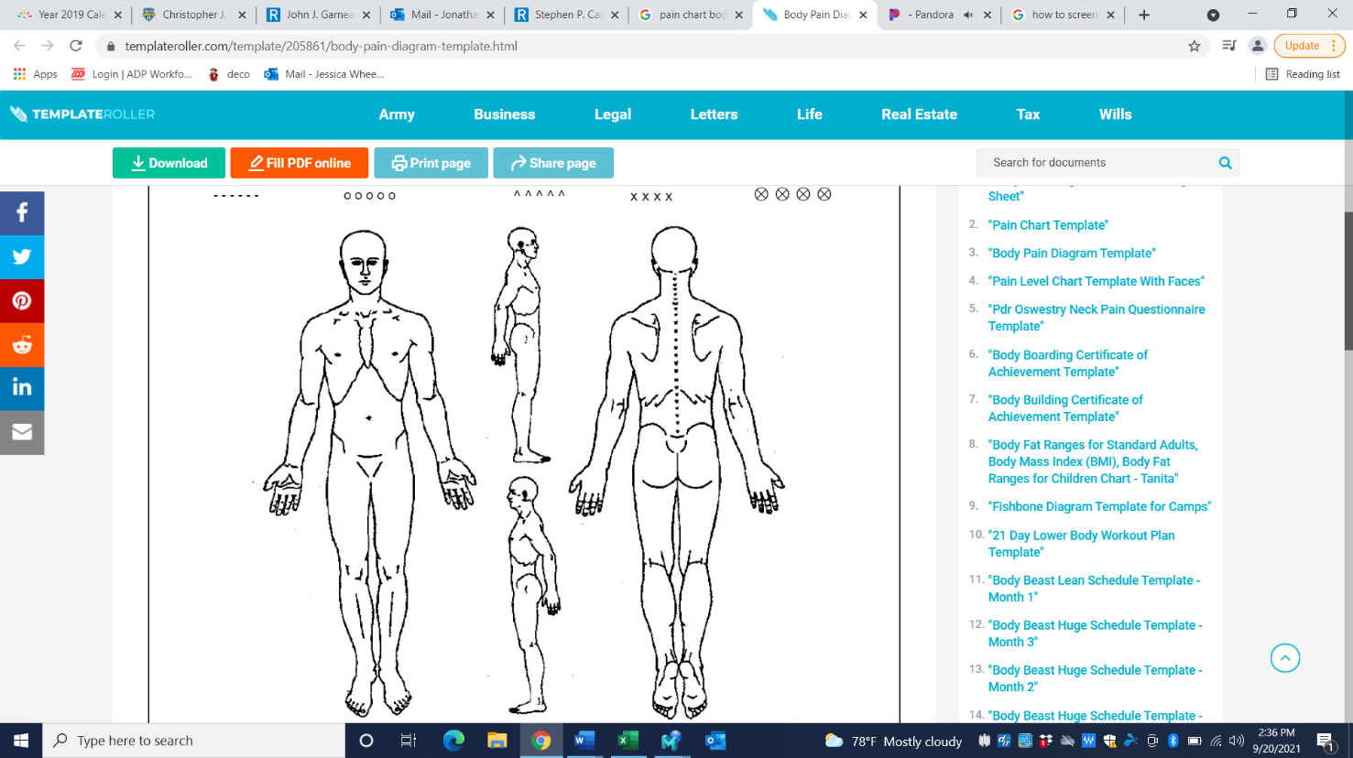

**CURRENT SYMPTOMS:**

YES NO Numbness or tingling YES NO Sleeplessness

YES NO Weakness or fatigue YES NO Loss of balance or falls

YES NO Ankle / leg swelling YES NO Blurred or double vision

YES NO Cold extremities YES NO Difficulty swallowing

YES NO Hoarseness YES NO Chronic cough

YES NO Coordination problems YES NO Concentration problems

YES NO Night sweats / fever / chills YES NO Memory Loss

**WOMEN ONLY:**

YES NO Are you pregnant or possibly pregnant?

YES NO Have you had a hysterectomy / post menopause?

**I hereby give consent for treatment for myself, or the named minor child, by the staff at Lattimore Physical Therapy and/or as directed by my referring physician.**

**___________________________________ __________________________________ ________________**

**Print Name Signature of patient, parent or guardian Date**